**Incremental Data Loading Pipeline Documentation**

**Goal**

Implement an incremental data loading strategy to process only new records from incoming CSV files, and maintain a cumulative dataset without duplications — based on a unique key (Code).

**Folder Structure**

Create the following directories on your Ubuntu machine:

***mkdir -p ~/Downloads/csv_incremental/data/new***

***mkdir -p ~/Downloads/csv_incremental/data/processed***

Where to place files:

Drop new CSV files (e.g. DimenLookupEthnic8277.csv) in:

***~/Downloads/csv_incremental/data/new/***

The script will maintain a cumulative processed file at:

***~/Downloads/csv_incremental/data/processed/processed_dimen_lookup.csv***

**Script: incremental_loader.py**

Save the following script to:

***~/Downloads/csv_incremental/incremental_loader.py***

***import os***

***import pandas as pd***

***new_data_dir = os.path.expanduser("~/Downloads/csv_incremental/data/new")***

***processed_file_path = os.path.expanduser("~/Downloads/csv_incremental/data/processed/processed_dimen_lookup.csv")***

***if os.path.exists(processed_file_path):***

***processed_df = pd.read_csv(processed_file_path, dtype=str)***

***print(f"[INFO] Loaded existing processed file with {len(processed_df)} rows.")***

***else:***

***processed_df = pd.DataFrame(columns=["Code", "Description", "SortOrder"])***

***print(f"[INFO] No processed file found. Starting fresh.")***

***for filename in os.listdir(new_data_dir):***

***if filename.endswith(".csv"):***

***file_path = os.path.join(new_data_dir, filename)***

***print(f"[INFO] Processing {filename}...")***

***new_df = pd.read_csv(file_path, dtype=str)***

***new_df = new_df.dropna(subset=["Code"])***

***new_rows = new_df[~new_df["Code"].isin(processed_df["Code"])]***

***print(f"[INFO] Found {len(new_rows)} new rows.")***

***if not new_rows.empty:***

***processed_df = pd.concat([processed_df, new_rows], ignore_index=True)***

***processed_df.to_csv(processed_file_path, index=False)***

***print(f"[INFO] Updated processed file saved with {len(processed_df)} total rows.")***

**How to Run the Pipeline**

***cd ~/Downloads/csv_incremental***

***python3 incremental_loader.py***

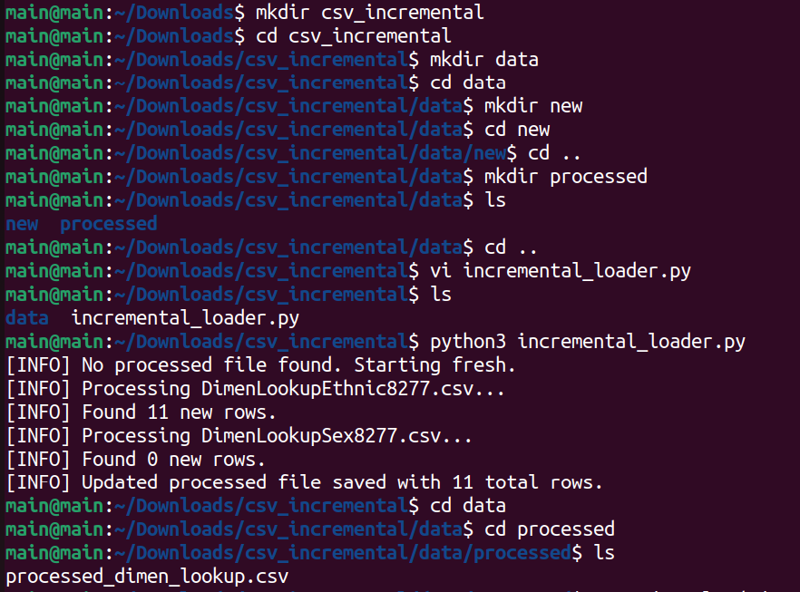

**Example of Incremental Load**

Initial state:

processed_dimen_lookup.csv has 11 rows from DimenLookupEthnic8277.csv.

New File:

Create a test file DimenLookupTestNew.csv in data/new/:

***Code,Description,SortOrder***

***9999,Total people,1***

***1,European,2***

***NEW-001,New Entry 1,1***

***NEW-002,New Entry 2,2***

Run the Script Again:

***python3 incremental_loader.py***

Expected Output:

[INFO] Loaded existing processed file with 11 rows.

[INFO] Processing DimenLookupTestNew.csv...

[INFO] Found 2 new rows.

[INFO] Updated processed file saved with 13 total rows.

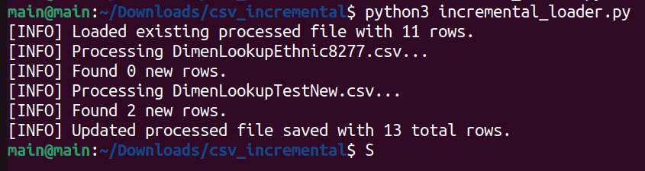



**Outcome**

This pipeline:

* Ingests new data from CSVs
* Filters out duplicates using Code as a unique identifier
* Appends only new rows to a persistent output file